^{ONLINE PAYMENT FRAUD DETECTION}
MENTOR:SRI L.LAKSHMI NARAYANA
TEAMID:LTVIP2026TMIDS46417
TEAM LEADER:VAIBOYINA DEVI
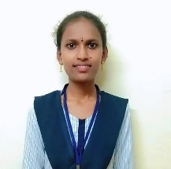Roll number:SBAP0040409 MAIL ID:deviyaiboina@gmail.com
MY TASKS
^{TSK:732075}
^{1)DATA COllECTION:}
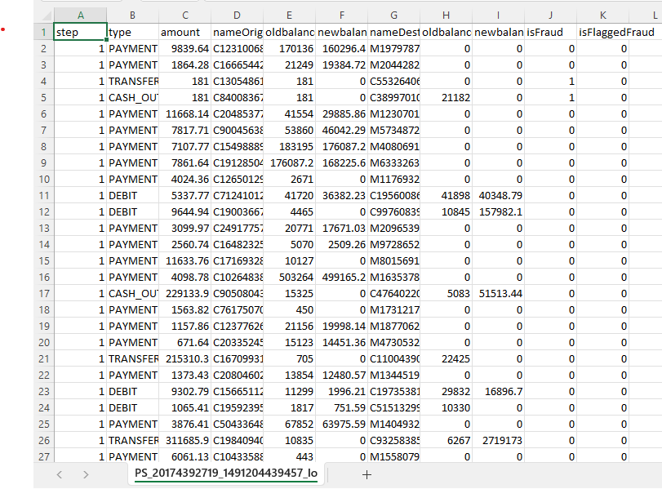

^{TSK:732076}
^{Visualizing and analyzing data}
^{IMPORTING LIBRARIES}
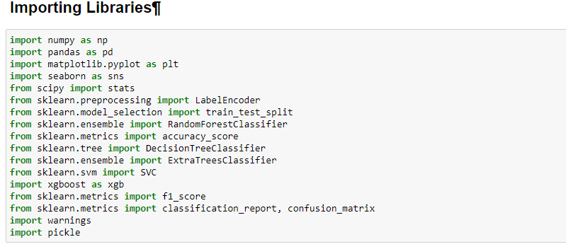
^{TSK:732077}
^{Read the dataset}
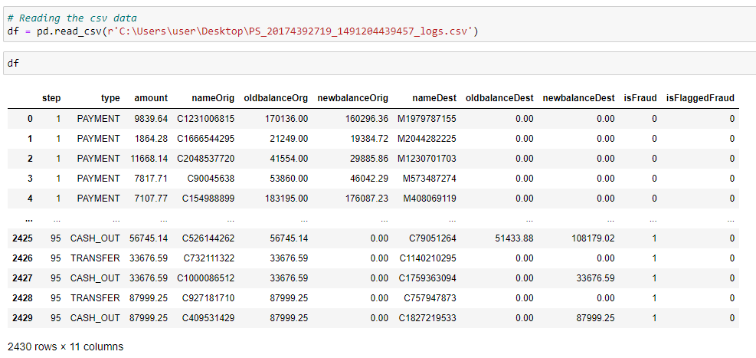
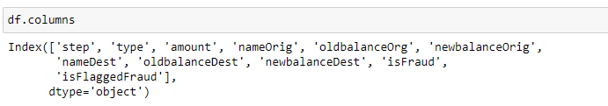
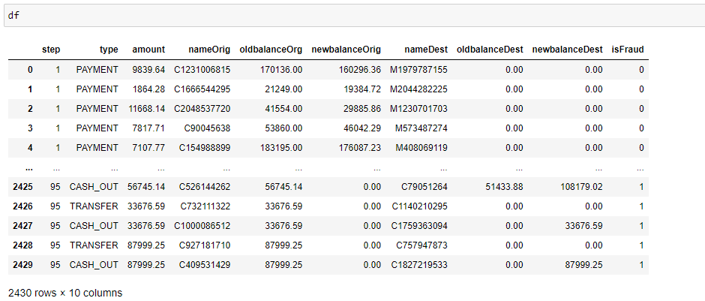
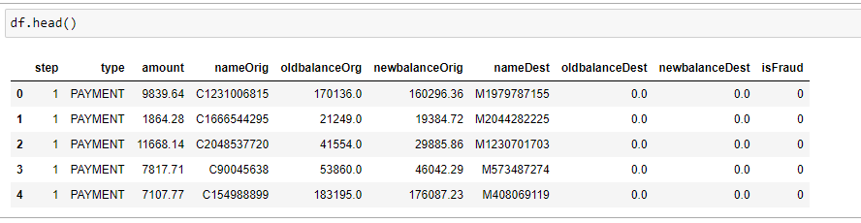
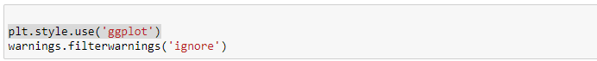
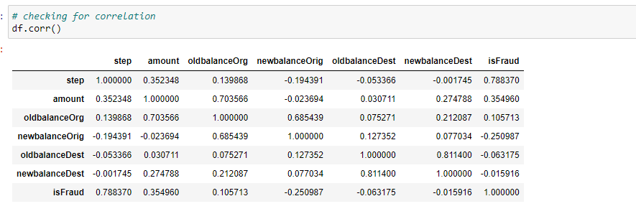
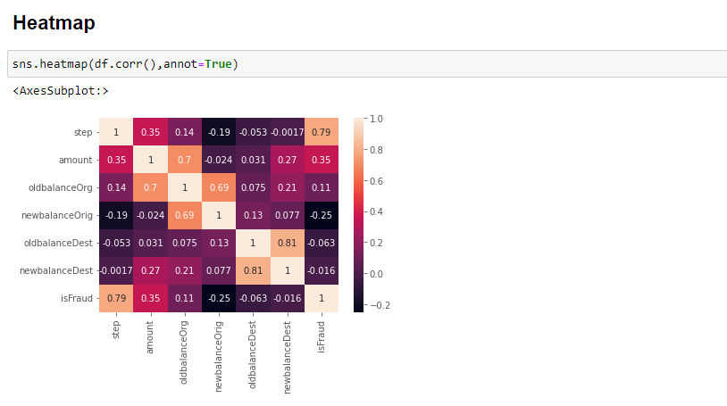
TSK:732088
Support Vector Machine Classifier
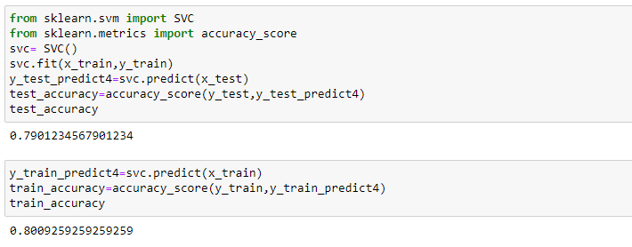
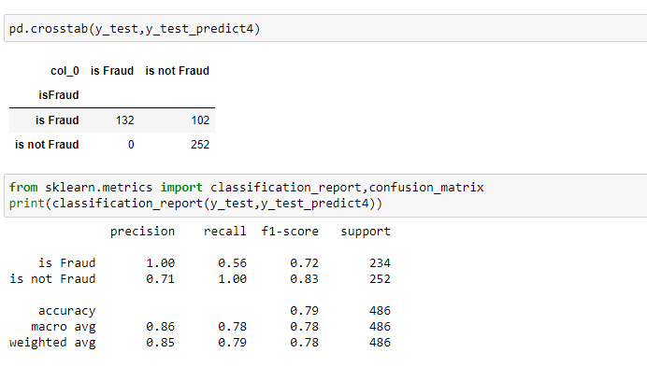
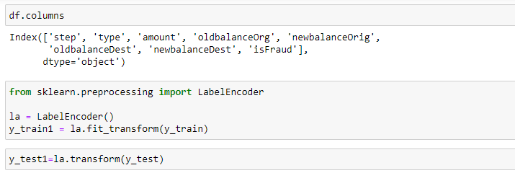
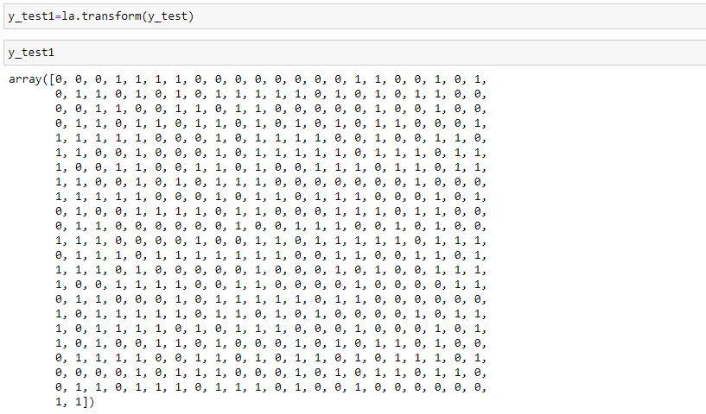

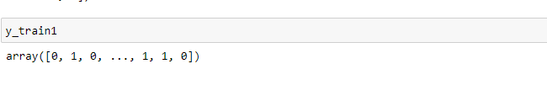
TSK:732093
- Build Python code
- 